**CHAPTER1**

**1 INTRODUCTION**

* 1. **PROJECT DETAILS**

**1.1.1 Project Definition**

Doctor Appointment Management System

A Doctor Appointment Management system is a software that contain tools and features that help the customers in scheduling appointments with doctors. Also known as doctor appointment booking software, these tools aid businesses in automating the process of scheduling appointment with doctors to provide services.

**1.1.2 About the Project**

Doctor appointment is a smart web application, this provides a registration and login for both doctors and patients. Doctors can register by giving his necessary details like timings, fee, category, etc. After successful registration, the doctor can log in by giving username and password. The doctor can view the booking request by patients and if he accepts the patient requests the status will be shown as booking confirmed to the patient. He can also view the feedback given by the patient.

* 1. **PURPOSE**

The purposes of the Doctor Appointment Management System are:

The proposed project is a smart appointment booking system that provides patients or any user an easy way of booking a doctor’s appointment online. This is a website-based application that overcomes the issue of managing and booking appointments according to user’s choice or demands. The task sometimes becomes very tedious for the compounder or doctor himself in manually allotting appointments for the users as per their availability. Hence this project offers an effective solution where users can view various booking slots available and select the preferred date and time.

**1.3 OBJECTIVE**

* The main objective of the project is to manage the details of Doctor, Appointment, Patient, Booking.
* It manages all information about Doctor, Appointment, Bookings.
* The purpose is to build application program to reduce the manual work for managing the Doctor, Appointment, Patient.
* It tracks all the details of the Patient, Doctor, Bookings.
  1. **SCOPE**

As the number of patients are increasing day by day with unhealthy lifestyle trends in India the need of doctors are also increasing to a great extent for health problem consultation. But it is sometimes not possible for the healthcare seekers to get doctor appointments at their desired time and date due to patient queues and doctor availability.

* 1. **SYSTEM ANALYSIS & DESIGN**

**Introduction**

Systems are created to solve problems. One can think of the systems approach as an organized way of dealing with a problem. In this dynamic world, the subject System Analysis and Design mainly deals with the software development activities.

**Objectives**

After going through this lesson, you should be able to:

* understand a system
* understand the different phases of system developments life cycle
* know the components of system analysis
* know the components of system designing

**Defining a system**

A collection of components that work together to realize some objective forms a system. Basically there are three major components in every system, namely input, processing and output.

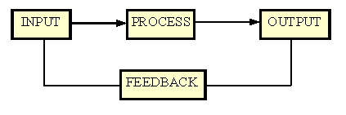

In a system the different components are connected with each other and they are interdependent. For example, Human body represents a complete natural system. We are also bound by many national systems such as political system, economic system, educational system and so forth. The objective of the system demands that some output is produced as a result of processing the suitable inputs.

**1.5 SYSTEM DEVELOPMENT LIFE CYCLE**

System life cycle is an organizational process of developing and maintaining systems. It helps in establishing a system project plan, because it gives overall list of processes and sub-processes required developing a system.

System development life cycle means combination of various activities. In other words we can say that various activities put together are referred as system development life- cycle.The System Analysis and Design terminology, the system development life cycle means software development life cycle.

Following are the different phases of software development cycle:

* System study
* Feasibility study
* System analysis
* System design
* Coding
* Testing
* Implementation
* Maintenance

The different phases of software development life cycle are shown below:

|  |  |  |  |  |
| --- | --- | --- | --- | --- |
|  |  |  | | |
|  |  |  | | |
|  |  |  | | |
|  |  |  | | |
|  |  |  | | |
| * 1. **PHASES OF SYSTEM DEVELOPMENT LIFE CYCLE:**   Let us now describe the different phases and the related activities of system development life cycle in detail.    **1.6.1 System Study:**  System study is the first stage of system development life cycle. This gives a clear picture of what actually the physical system is? In practice, the system study is done in two phases. In the first phase, the preliminary survey of the system is done which helps in identifying the scope of the system. The second phase of the system study is more detailed and in-depth study in which the identification of user’s requirement and the limitations and problems of the present system are studied. After completing the system study, a system proposal is prepared by the System. Analyst (who studies the system) and placed before the user. The proposed system contains the findings of the present system and recommendations to overcome the limitations and problems of the present system in the light of the user’s requirements.  To describe the system study phase more analytically, we would say that system study phase passes through the following steps:   * problem identification and project initiation * background analysis * inference or findings   **1.6.2 Feasibility Study**:  On the basis of result of the initial study, feasibility study takes place. The feasibility study is basically the test of the proposed system in the light of its workability, meeting user’s requirements, effective use of resources and of course, the cost effectiveness. The main goal of feasibility study is not to solve the problem but to achieve the scope. In the process of feasibility study, the cost and benefits are estimated with greater accuracy.    **1.6.3 System Analysis:**  Assuming that a new system is to be developed, the next phase is system analysis. Analysis involved a detailed study of the current system, leading to specifications of a new system. Analysis is a detailed study of various operations performed by a system and their relationships within and outside the system. During analysis, data are collected on the available files, decision points and transactions handled by the present system. Interviews, on-site observation and questionnaire are the tools used for system analysis.    Using the following steps it becomes easy to draw the exact boundary of the new system under consideration:   * Keeping in view the problems and new requirements * Workout the pros and cons including new areas of the system     All procedures, requirements must be analyzed and documented in the form of detailed data flow diagrams (DFDs), data dictionary, logical data structures and miniature specifications. System Analysis also includes sub-dividing of complex process involving the entire system, identification of data store and manual processes.    The main points to be discussed in system analysis are:   * Specification of what the new system is to accomplish based on the user requirements. • Functional hierarchy showing the functions to be performed by the new system and their relationship with each other. * Function network which are similar to function hierarchy but they highlight those functions which are common to more than one procedure. * List of attributes of the entities - these are the data items which need to be held about each entity (record)   **1.6.4 System Design:**  Based on the user requirements and the detailed analysis of a new system, the new system must be designed. This is the phase of system designing. It is a most crucial phase in the development of a system. Normally, the design proceeds in two stages:   * preliminary or general design * Structure or detailed design     Preliminary or general design: In the preliminary or general design, the features of the new system are specified. The costs of implementing these features and the benefits to be derived are estimated. If the project is still considered to be feasible, we move to the detailed design stage.  Structure or Detailed design: In the detailed design stage, computer oriented work begins in earnest. At this stage, the design of the system becomes more structured. Structure design is a blue print of a computer system solution to a given problem having the same components and inter-relationship among the same components as the original problem. Input, output and processing specifications are drawn up in detail. In the design stage, the programming language and the platform in which the new system will run are also decided.    There are several tools and techniques used for designing. These tools and techniques are:   * Flowchart * Data flow diagram (DFDs) * Data dictionary * Structured English * Decision table * Decision tree   **1.6.5 Coding:**  After designing the new system, the whole system is required to be converted into computer understanding language. Coding the new system into computer programming language does this. It is an important stage where the defined procedures are transformed into control specifications by the help of a computer language. This is also called the programming phase in which the programmer converts the program specifications into computer instructions, which we refer as programs. The programs coordinate the data movements and control the entire process in a system. It is generally felt that the programs must be modular in nature. This helps in fast development, maintenance and future change, if required.    **1.6.6 Implementation:**  After having the user acceptance of the new system developed, the implementation phase begins. Implementation is the stage of a project during which theory is turned into practice. During this phase, all the programs of the system are loaded onto the user's computer. After loading the system, training of the users starts.    Main topics of such type of training are:   * How to execute the package * How to enter the data * How to process the data (processing details) * How to take out the reports     After the users are trained about the computerized system, manual working has to shift from manual to computerized working. The following two strategies are followed for running the system:   1. Parallel run: In such run for a certain defined period, both the systems i.e. computerized and manual are executed in parallel. This strategy is helpful because of the following: o Manual results can be compared with the results of the computerized system. o Failure of the computerized system at the early stage, does not affect the working of the organization, because the manual system continues to work, as it used to do. 2. ii. Pilot run: In this type of run, the new system is installed in parts. Some part of the new system is installed first and executed successfully for considerable time period. When the results are found satisfactory then only other parts are implemented. This strategy builds the confidence and the errors are traced easily. | | |  |  |
| **1.6.7 Maintenance:**  Maintenance is necessary to eliminate errors in the system during its working  life and to tune the system to any variations in its working environment. It has been seen that there are always some errors found in the system that must be noted and corrected. It also means the review of the system from time to time.    The review of the system is done for:   * knowing the full capabilities of the system * knowing the required changes or the additional requirements * studying the performance     If a major change to a system is needed, a new project may have to be set up to carry out the change. The new project will then proceed through all the above life cycle phases.  **1.7 DATABASE DESIGN**  **1.7.1 The Entity-Relationship Model**  The Entity-Relationship (E-R) model was developed to facilitate database design by allowing specification of an enterprise schema that represents the overall logical structure of a database. The E-R data model is one of the several semantics data models. the semantic aspect of the model lies in its representation of the meaning of the data. The E-R model is very useful in mapping the meanings and interactions of real world enterprises onto conceptual schema. The E-R data model has three basic notions: entity-sets, relationship sets and attributes.    **Entity sets:**  An entity is a thing or object in the real world that is distinguishable from all other objects. It has a set of properties, and the values for some set of properties may uniquely identify an entity. It is also a set of entities of the same type that share the same properties.    **Relationship sets:**  A relationship is an association among several entities. It is a set  of relationships of the same type. The association between entity sets is referred to as participation. The function that an entity plays in a relationship is called that entity’s role.    **Attributes:**  An entity is represented by a set of attributes. Attributes are descriptive properties possessed by each member of an entity set. The designation of an attribute for an entity set expresses that the database stores similar information concerning each entity in the entity set; however, each entity may have its own value for each attribute. Some important features of E-R model:    **Mapping Cardinality:**  Mapping cardinalities express the number of entities to which another entity can be associated via a relationship set.Cardinality can be---    **One-to-one:** An entity of a set can be associated with at most one entity of  another.    **One-to-many:** An entity of a set is associated with any number (entities)of  another set.  **Many-to-one:** An entity (1st set) is associated with at most one entity (of  2ndset). But 2nd set’s entity can associate with any number of 1st entity set.    **Many-to-many:** Entities of both sets can be associated with any number of  entities between them.    **1.7.2 Normalization**    Boyce Codd introduced a number of ‘normal forms’ (1970- 1972). They are principles that can hold for a given relation or not.    The formal definition of Normalization is: it is the sequence of steps by which are relational database model is both created and improved upon. The sequence of steps involved in the normalization process is called normal forms. Essentially, normal forms applied during a process of normalization allow creation of a relational database model as a step-by-step progression.    **Normal Forms:**  **First Normal Form (1NF):** A relation is in first normal form if it contains only simple , atomic values for attributes, no sets; that is, if attributes do not have sub attributes.  Example: Name Place  Karim Dhaka  Rahim Comilla  This relation is in first normal form because attributes do not have sub attributes.    **Second Normal Form (2NF):** A relation is in second normal form, if it is in 1NF and every non primary key attribute is fully functionally dependent on the primary key of their relation. Example: Relation :( A, B, C, D) {A} = > {B} {A} = > {C} {A} = > {D} It is in 2NF because it is in 1NF and every non-primary key attribute is fully functionally dependent on the primary key of the relation.    **Third Normal Form (3NF):** A relation is in third normal form, if it is in 2NF and no nonprimary key attribute is transitively dependent on the primary key. Example: Relation :( A, B, C, D, E) {A, B} = > {C} {A, B} = > {E} This relation is in third normal form because it is in 2NF and no non-primary key attribute is transitively dependent on the primary key.    **Boyce - Codd Normal Form (BCNF):** A relation is in BCNF, if for every full functional dependency X = > Y holds: X is a candidate key. If part of primary key is fully functionally dependent on non-primary key, BCNF violation occurs. Example: Relation :( A, B, C, D ) {A, B} = > {C, D} {C} = > {A} In 1NF, 2NF, 3NF,but not in BCNF. Because part of primary key, A is fully functionally dependent on non-primary key C. We have to split the original relation. (A, B, D), (C, A). Now in BCNF.  **Advantages of normalization:**   1. Many unnecessary redundancies are avoided. 2. Anomalies with input, deletion and updates can be avoided. 3. Fully normalized, relations tend to need less space than if not normalized.     **Disadvantages of normalization:**   1. Normalization splits entities and relationships into many relations, thus making them harder to understand. 2. Queries become more complex because they have to involve more relations. 3. Response times are longer because of a higher number of joins in the queries.     **1.7.3 Database Architecture:**  Database architecture is logically divided into two types.   1. Logical two-tier Client / Server architecture 2. Logical three-tier Client / Server architecture     **Two-tier Client / Server Architecture:**  Two-tier Client / Server architecture is used for User Interface program and Application Programs that runs on client side. An interface called ODBC (Open Database Connectivity) provides an API that allow client side program to call the DBMS Most DBMS vendors provide ODBC drivers. A client program may connect to several DBMS's. In this architecture some variation of client is also possible for example in some DBMS's more functionality is transferred to the client including data dictionary, optimization etc. Such clients are called Data server.    **Three-tier Client / Server Architecture:**  Three-tier Client / Server database architecture is commonly used architecture for web applications. Intermediate layer called Application server or Web Server stores the web connectivity software and the business logic(constraints) part of application used to access the right amount of data from the database server. This layer acts like medium for sending partially processed data between the database server and the client. | | |  |  |
|  |  |  | | |
|  |  |  | | |

**CHAPTER 2**

1. **REQUIRNEMENT ANALYSIS**

**2.1 INTRODUCTION TO DATABASE:**

**2.1.1 XAMPP Server**

**XAMPP Server** refers to a software stack for the Microsoft Windows operating system, created by Romain Bourdon and consisting of the Apache web server, Open SSL for SSL support, MySQL database and PHP programming language

**2.1.2 PHP**

**PHP** is a server-side scripting language designed primarily for web development but also used as a general-purpose programming language. Originally created by Rasmus Lerdarf in 1994, the PHP reference implementation is now produced by The PHP Development Team. PHP originally stood for Personal Home Page, but it now stands for the recursive acronym PHP :Hypertext Pre-processor.

PHP code may be embedded into HTML or HTML markup or it can be used in combination with various web template systems, web content management systems and web frameworks. PHP code is usually processed by a PHP interpreter implemented as a module in the web server or as a Common Gateway Interface (CGI) executable. The web server software combines the results of the interpreted and executed PHP code, which may be any type of data, including images with the generated web page. PHP code may also be executed with a command-line interface (CLI) and can be used to implement standalone graphical applications.The standard PHP interpreter, powered by the Zend Engine, is free software released under the PHP License. PHP has been widely ported and can be deployed on most web servers on almost every operating system and platform, free of charge.

The PHP language evolved without a written formal specification or standard until 2014, leaving the canonical PHP interpreter as a de facto standard. Since 2014 work has gone on to create a formal PHP specification.

**2.1.3MySQL**

MYSQL is an Open-source relational database management system. Its combination of “My”, the name of co-founder Michael Widenius’s daughter, and SQL the abbreviation for Structured Query Language. The MySQL development project has made its source code available under the terms of the GNU General Public License,as well as under a variety of proprietary agreements. MySQL was owned and sponsored by a single for-profit firm, the Swedish company MySQL AB, now owned by Oracle Corporation. For proprietary use, several paid editions are available, and offer additional functionality.

**CHAPTER 3**

1. **REQUIREMENTS SPECIFICATION**

**3.1 Hardware Requirements:**

Microprocessor - Intel Pentium 4 or higher

Hard Disk Capacity - 40 GB or more

RAM - 4GB or more

Keyboard - Standard Keyboard with 104 keys

Mouse - 2 or 3 Button Mouse

Monitor - 1366 x 768 display resolution with true colour

* 1. **Software Requirements**:

Operating System - Windows10

Front End – PHP, HTML,CSS, JavaScript ,Bootstrap

Back End - My SQL

Technology – Xampp Server

Server - Apache Web Server

**CHAPTER 4**

1. **IMPEMENTATION**
   1. **Schema Diagram**

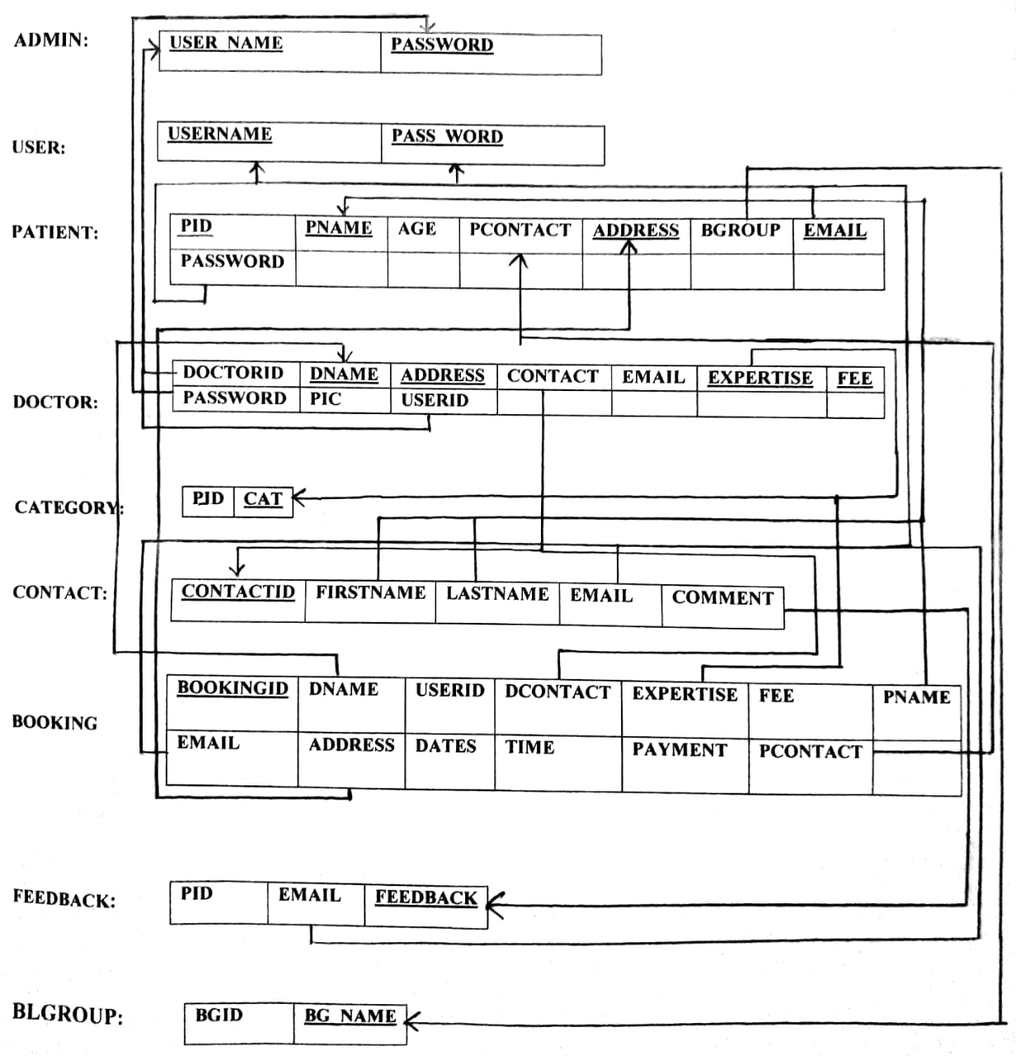

**4.2 Entity-relationship diagram:**

Category

**m**

Falls in

Admin

contact

**n**

Can have

**1**

**1**

Can be

Books

Patient

**n 1 n**

Booking

**1**

gives

views

**n n**

**n m**

Feedback

Doctor

* 1. **Source Code:**

This is index and login page:

<?php include('header.php'); ?>

<!-- this is for welcome -->

<div class="content">

<article>

<p class="text-justify" >One of the complex disciplines in the world happens to be health and medicine. Both these go hand-in-hand in order to determine the quality of life. These concern various parameters like diagnosis, prevention, treatment, and cure. Since there are various illnesses and diseases, it is common to find a huge array of medical treatment options. The diversity is quite impressive, as there are various programs like pharmacology, nutrition, dental technology, biomedicine, physiotherapy, psychology, and more. Let's find out more about medical treatment essay writing in this article.

</p>

</article>

</div><br>

<!-- nivo slider starts -->

<div class="col-md-12 sliderImg">

<img src="img/images1.jpg" alt="">

<img src="img/images2.jpg" alt="">

</div>

<!-- nivo slider ends -->

<!-- main Content -->

<div class="main_content">

<div class="col-md-8">

<article>

<h3 style="font-weight:bold;font-family:inherit;color:#2E4053; ">DOCTORS AT YOUR DOORSTEPS:) </h3><hr>

<p class="text-justify">Doctors are medical professionals. They are qualified and trained health care professionals who diagnose and treat various health conditions in human beings. There are various branches of medicine. Doctors specialize in studying and treating diseases of the different parts of the body. For example, cardiologists, ophthalmologists, dentists, neurologists and dermatologists are specialists in treating diseases of specific parts of the human body.When one feels sick or has got an injury one visits the doctor. A doctor can diagnose the health condition a person is suffering from. Unless one’s disease or ailment is diagnosed, proper treatment cannot be given to cure and restore the health of the person.

Doctors specialize in particular fields of medicine. They study specific organs or parts of the body in detail. They are experts in treating diseases that affect these parts of the body. For example, there are doctors who specialize in treating diseases of the nerves, and are known as neurologists. Similarly, the study of bones and its diseases comes under orthopaedics. While pulmonary specialists are experts in dealing with the diseases and health of the lungs, cardiologists deal with the health of the heart.</p>

</article>

</div>

<div class="col-md-4">

<h3 class="text-center" style="font-weight:bold;font-family:inherit;">NEED APPOINTMENT?</h3><hr>

<ul class="text-justify">Meet Our Medical Doctors

Our Medical Doctors are educated and trained at some of the Finest Medical Colleges and Hospitals of the Country. They further go through a rigorous selection process whereby we choose only the ones who have in-depth knowledge, are committed to Patient Satisfaction and get high ratings from their peer group of Doctors.

</ul></div>

</div>

<?php include('footer.php'); ?>

</div> <!-- containerFluid Ends -->

<script src="js/jquery-1.9.0.min.js"></script>

<script src="js/bootstrap.min.js"></script>

</body>

</html>

<?php include('header.php'); ?>

<!-- this is for donor registraton -->

<div class="login" style="background-color:#fff;">

<h1 class="text-center" style="background-color:#0616BC;color: #fff;padding: 5px;">LOGIN</h1>

<form action="" method="post" class="">

<div class="col-md-12">

<div class="col-md-4"></div>

<div class="col-md-4">

<label>Email: <input type="email" name="email" placeholder="email" required>

</label><br><br>

<label>Password: <input type="password" name="password" placeholder="password" required>

</label><br><br>

<!-- <button name="submit" type="submit">Login</button> <br> -->

<input type="submit" value="Login" name="submit">

<!-- login validation -->

<?php

// $_SESSION['userstatus']="";

include('config.php');

if(isset($_POST["submit"])){

$sql= "SELECT * FROM donarregistration WHERE email= '" . $_POST["email"]."' AND password= '" . $_POST["password"]."'";

$result = $conn->query($sql);

if ($result->num_rows > 0) {

// $_SESSION["email"]= $_POST["email"];

// $_SESSION['userstatus']= "yes";

echo "<script>location.replace('donor/index.php');</script>";

// echo "u are supposed to redirect to ur profile";

} else { echo "<span style='color:red;'>Invalid username or password</span>";

}

$conn->close();

?>

<!-- login validation End-->

</form><br><br>

Not A User?<a href="allregistration.php" style="color:#C30">Click here</a> to Register.

</div>

<div class="col-md-4"></div>

</div> <!-- col-md-12 -->

</div>

<?php include('footer.php'); ?>

</div><!-- containerFluid Ends -->

<script src="js/bootstrap.min.js"></script>

</body>

</html>

**CHAPTER 5**

**5 PROJECT SCREENSHOTS:**

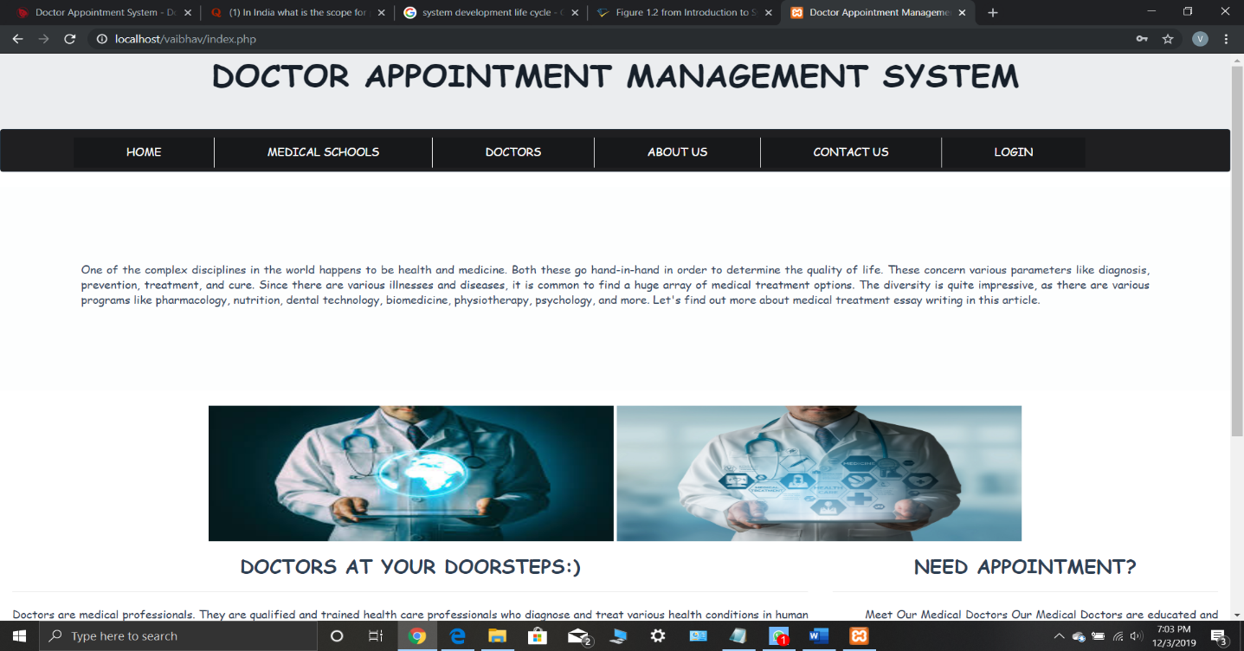

**5.1 Home page**

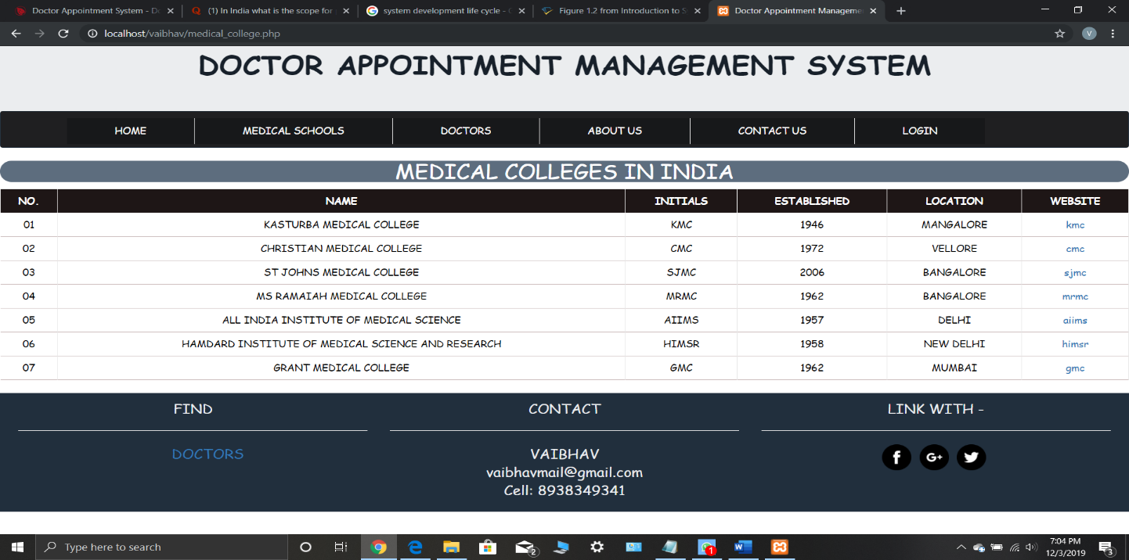

**5.2 Contents page**

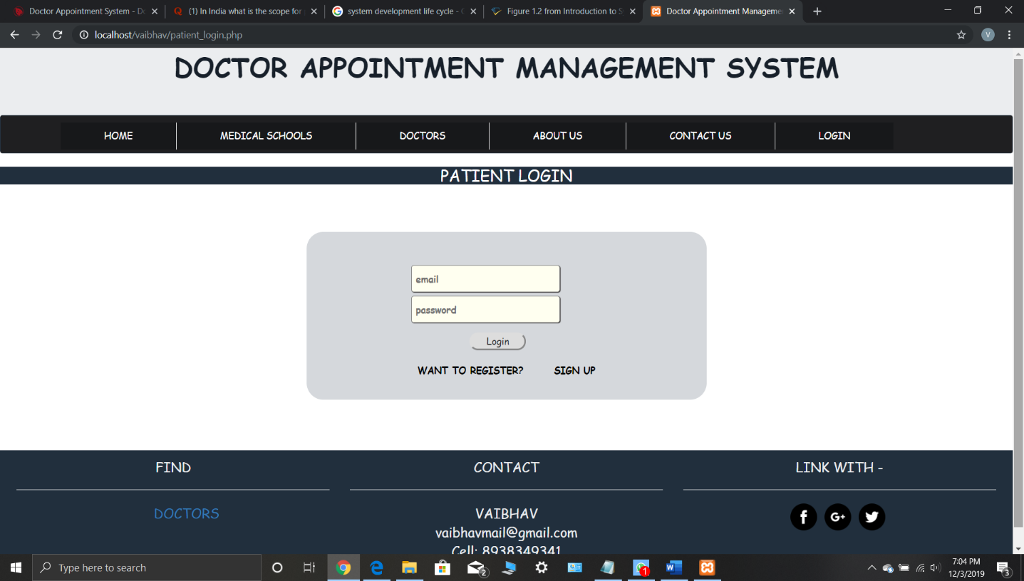

**5.3 Patient login**

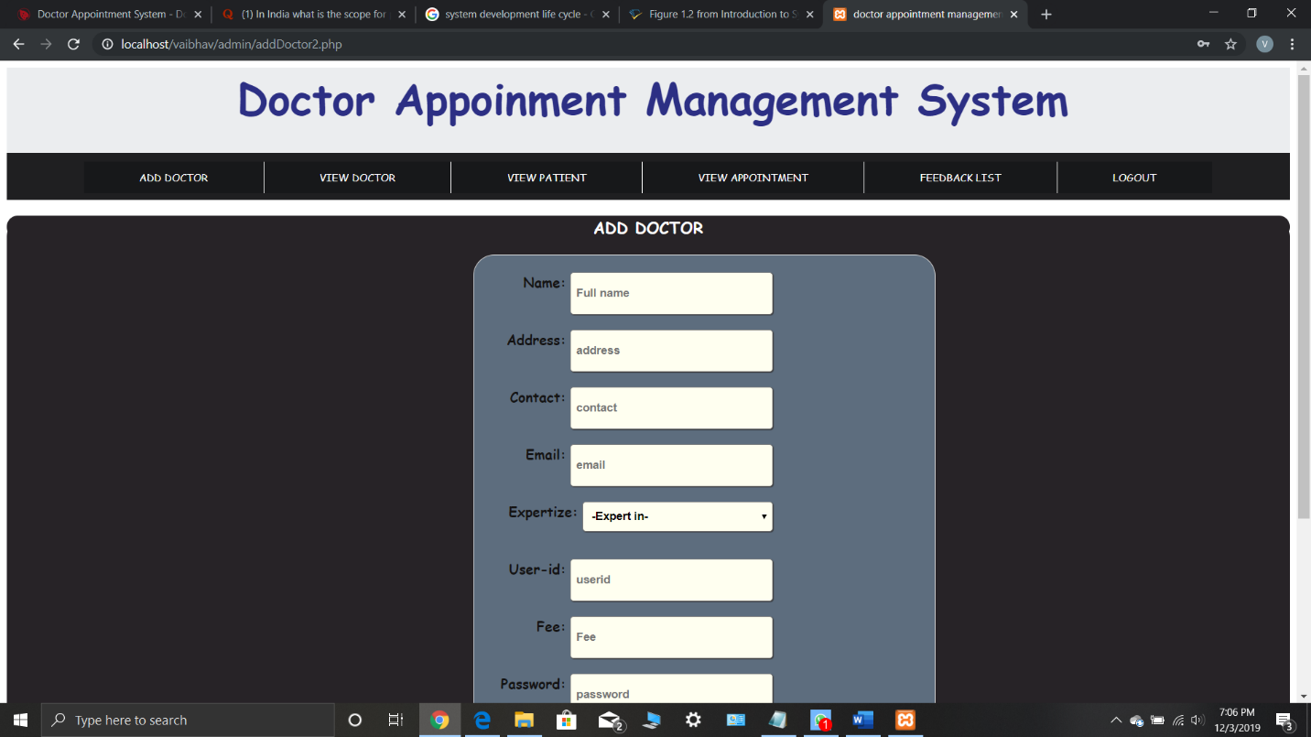

**5.4 Admin login**

**CHAPTER 6**

**6 RESULT & CONCLUSION**

The project has been successfully completed but further it could have been enhanced. I learnt a lot of things while doing this project, which can prove very useful in the software field.

By user’s point of view, the XAMPP Server software is very easy to use. Also it is the most widely used application in creating a Database. The designers developed the phpMyAdmin which allow us to create, insert and manipulate the Database. Using which we can develop the Front-End and the Back-End linking process**.**

As the part of our Academic Project we have successfully learnt how to create and maintain a Database.

This project has enabled me to properly run and implement the Doctor Appointment Management System DBMS Project giving me a more practical application of the whole idea**.**

**BIBLIOGRAPHY**

**BOOKS:**

* HTML & CSS: The Complete Reference

Thomas A. Powell, 5th edition, McGraw-Hill Digital, 2010.

* PHP: The Complete Reference

Steven Holzner, McGraw-Hill Education, 2008.

**WEBSITES:**

* [www.w3schools.com](http://www.w3schools.com)
* [www.google.com](http://www.google.com)